SYSTEM & MAINTENANCE MANUAL
FOR
MOTORIZED ROLLING SHUTTER

CLIENT: M.A ENGINEERING
PROJECT: JOHN DEERE
MFG.YEAR: - 2020

DESIGNED, DEVELOPED & MARKETED
BY



G-BLOCK, 1ST FLOOR, THERMAX CHOWK
MIDC, ABOVE RENAULT SHOWROOM
CHINCHWAD, PUNE-411019

TEL.NO: - +912066304033
EMAIL:-info@nihva.com
www.nihva.com

MOTORIZED ROLLING SHUTTER
SIZE | 3m X 3.580m
SR NO
CLIENT | M.A ENGINEERING

DESPATCH & UNLOADING

- Loading, for dispatch, will be our responsibility. On receipt of the Rolling Shutter at site, please check and ensure that there is no physical damage to the equipment.

- While unloading the equipment from the transporting vehicle, please ensure to use slings with rated capacity higher than the gross weight of the Stationary lift in packed condition.

ORDERING OF SPARES

  - When ordering for spare, please specify the following in your Purchase Order.

    - Shutter Size
    - Part name / Description
    - Quantity required
    - Delivery period / time
    - Mode of dispatch

This would avoid ambiguity and help us serve you better.

      - EMERGENCY CONTACT DETAILS: -

        - Santosh Bangar - 9168938333
        - Pradip Ubhe - 7709586333

DATA SHEET FOR MOTOURISED ROLLING SHUTTER:

1.0 CONSTRUCTION DETAILS:

- Shutter operation mode
- Operation control
- Material
:
:
:
230V AC/440 V AC
By push buttons
G.I
Motor Specification:
1.Motor Type
:
Indirect Drive
2.Motor Make
:
3.Motor Rating
:
In watt
4.Working Temperature
:
-15 to 45 deg C
- Continuous Single-Phase operation should not exceed 7 min
.
- Continuous Three-Phase operation should not exceed 15 min.

Jielong make

INTRODUCTION: -

The Motorized Rolling Shutter is the result of many years’ experience in Door Automation Technologies. “NIHVA” offers the best possible factor of safety with simple, easy to use controls. The high quality of manufacture gives a robust construction and many years of useful life. Each operation opens and closed movement can be individually controlled (or corrected) by push button

We take pride that our product & service range is offered with a high level of working safety, comfort, functionality and supported by services and added value solutions.

PRE – OPERATING INSTRUCTIONS: -

Check the door is not locked in any way and that there are no obstructions that may prevent the door from opening.

- Check that the area is clear of all personnel.

- In the event of a power failure, the door is supplied with a manual over ride system. This is via a hand Chain and should only be used in emergencies. PLEASE NOTE that the emergency manual over ride system is not designed for everyday use and that excessive use will cause premature failure.

- Ensure the shutter greasing properly.

ROUTINE MAINTENANCE

These recommendations are applicable to the Motorized rolling shutter considering average daily usage of 15 to 20 times. If it is used more frequently, the same time intervals for the maintenance should be adjusted accordingly.

DAILY:

- Check shutter lock is open before operation.
- Check electrical connections for their proper working.
- Visual inspection for damages

MONTHLY:

- Greasing between Guide and slats.
- Check all Parts for wear out or damage. Check all fixing are secure.
- Check correct operations of control button. Greasing to chain & bearing.

ASSEMBLIES & SPARE PARTS LIST:

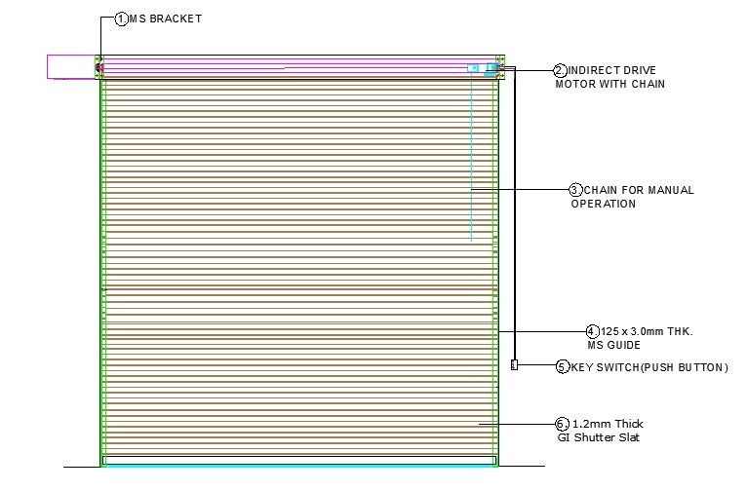

Rolling Shutter (3 x 3.580 MTR.)

SR. No | Item Description | Unit | QTY
1 | MS Bracket | Pc. | 2
2 | Indirect Drive Motor with chain | Pc. | 1
3 | Chain for Manual | MTR. | 4
4 | Guide | MTR | 3
5 | Slats width | MTR. | 3.10
6 | Push Button | Set. | 1
7 | Gasket | MTR. | 3

GA DRAWING:



